**Design and Implementation of a Digital Parking Lot Management System**

by

Xiaolong Li Uma Kanth Ranga

Elec., Comp. & Mech. Engineering Technology ECMET student

Indiana State University Indiana State University

[xli3@isugw.indstate.edu](mailto:xli3@isugw.indstate.edu) [uranga@mymail.indstate.edu](mailto:uranga@mymail.indstate.edu)

**Abstract *-*** This project aims at implementing a digital vehicle management system using radio frequency identification (RFID) technology. This digital vehicle management system will enhance the utilization of parking space and help user check the availability of the parking space remotely since the system is connected to the Internet. The project will be implemented in four stages. The first stage consists of embedding the code into a tag and assigning the same to a car. The second stage is reading the data from the RFID tag to the microcontroller. In the third stage, the data is uploaded from microcontroller to the Ethernet network. The final stage is to keep a track of vacancies of the parking spaces.

**I. Introduction**

According to the U.S. Bureau of Transit/Transportation statistics for the year of 2006, there are 250,851,833 registered passenger vehicles in the United States. These 251 million vehicles include cars, motor cycles, SUVs and pick-up trucks. The New York Times magazine states that approximately a million passenger vehicles are introduced into the roads each year in the United States, which ultimately leads to a parking problem due to limited availability of spaces. A survey conducted by one of the car manufacturing company, Bavarian Motor Works (BMW), shows that 20% of the inner traffic of major cities across the nation is in search of parking space.

At Indiana State University (ISU), 1400 parking spaces are available to the students as against that more than 4000 parking passes have been issued to students in the year of 2008. The parking system at ISU, just as the most normal parking systems, does not track the number of cars present in the parking lot, to say nothing of providing the information of vacancies online. A student has to drive into the parking lot and to search for available space, which results in a waste of time, effort and fuel.

In order to enhance the utilization of the parking lot and reduce the effort of finding a parking space, there is a need to build a digital parking lot management system for the public. With the rapid development of communication and computer technologies, it is possible to achieve this goal. In this project, the RFID technology has been used to maximize parking utilization. The RFID kit includes RFID windshield tags and RFID readers. The RFID reader is connected to a microcontroller in the control office where the system is connected to the Internet. As shown in Figure 1, where a car with enabled RFID windshield tag drives up to the gate, the RFID reader will automatically read the information from tag through the built in antenna. The received information will be delivered to the microcontroller where the information will be verified. If the received information matches the information in the database, the control office will send a command to open the barrier. The number of cars in the parking lot and the number of available spaces will be updated online immediately so that remote user can get the correct parking information.

This parking lot management system enables user to operate an unattended parking barrier with controlled parking access privileges. The system is ideal for apartments and condos, gated communities, business parking lots and garages, university parking areas and recreation operations from hotel to RV camps.

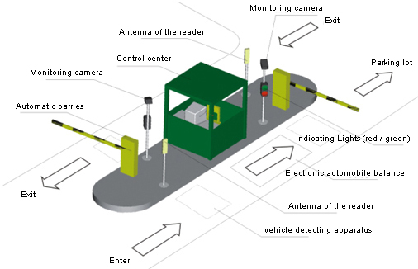

Figure 1: Parking lot management system [1]

**II. Background**

Introduction to RFID

RFID is a technology that incorporates the use of electromagnetic or electrostatic coupling in the radio frequency portion of the electromagnetic spectrum to uniquely identify an object, animal, or a person. The main advantage of using RFID is that it does not require direct contact or line-of-sight scanning. Figure 2 shows the basic infrastructure of an RFID system. The simplest RFID system has three major components:

* An RFID tag – transponder.
* An RFID reader – transceiver.
* A predefined protocol for the information transferred.

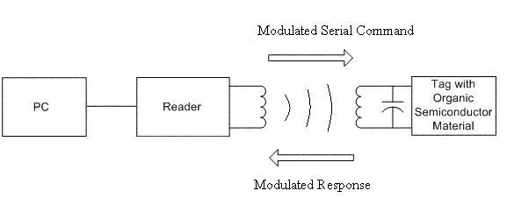

Figure 2: Basic infrastructure of RFID system

An antenna is connected to the RFID reader to communicate with the transponders. It sends out the electromagnetic field in a short range. The RFID tag is activated when it passes through a radio frequency field and sends out the programmed response. The RFID tag has a small computer chip that is programmed with the information that uniquely identifies the tag. The RFID tag can be passive or active. A passive RFID tag does not contain its own power source; rather, it absorbs energy propagated from a RFID reader’s antenna to supply all the power it needs to wake up its chip and communicate with the RFID reader. Unlike passive RFID tag, an active RFID tag has built with a battery inside it to energize the tag. Because active RFID tag uses an internal battery, its signal strength is a lot higher than passive tag and therefore can be read from a further distance.

RFID readers are the electronic components that transmit and/or receive the RF waves used to communicate with the tags. The primary components of the reader are an antenna, IC board, and memory [2].

The applications of RFID are ubiquitous. It can be used for inventory tracking, animal tracking, transportation payments, employee identification, newly born infant identification, and industrial automation and access control. RFID technology solutions are receiving much attention in the research and development of many large corporations.

## Introduction to Microcontroller

Microcontrollers are an advancement of microprocessors with memory in it. Although Intel designed 8051 in the year of 1980, it is still a powerful microprocessor in today technology market. Later years Intel allowed other manufacturers to make and market any flavor of the 8051 they please with the condition that they remain code-compatible with the original Intel’s 8051. Today, the market has been largely superseded by a vast range of faster and/or functionally enhanced 8051-compatible devices manufactured by more than 20 independent manufacturers [3]. The microcontroller used in this project is Silicon lab’s C8051. C8051 is an 8-bit microcontroller with 128 bytes of RAM, 4K bytes of on-chip ROM, two timers, one serial port, and four I/O ports (each 8-bits wide) [4].

**III. Implementation**

Design of the system

The block diagram of parking lot management system is shown in Figure 3.



Figure 3: Block diagram of parking lot management system

The project is implemented in four stages:

* + - 1. *Writing into the tag*: By making use of the write capability of the RFID reader, RFID tag is embedded with unique identification code and is assigned to a car. The tag contains distinct information about the car, like employee ID number or name or any other distinct data. This step accomplishes the data feed to the tag. This is similar to embedding information on a magnetic strip and the process is called writing.
      2. *Reading from the tag*: The information from the tag needs to be read during the car parking. In this step, the data is read from the tag with the help of an RFID reader.
      3. *Data feed to the microcontroller*: The data from the RFID reader has to be transferred to the microcontroller for the actual comparison of data and further processes. During this phase the data from the RFID reader is fed to the microcontroller using RS232 or UART media.
      4. *Data transfer to Ethernet*: There should be a provision for transfer of data from the microcontroller to an Ethernet port for the purposes of displaying information for remote people regarding the availability of parking spaces. However, the microcontroller is not compatible with the Ethernet in terms of transfer protocols. Thus, an AB4 Ethernet development board is needed so that the information can be properly transferred to the TCP/IP protocol.
      5. *Tracking the count.* To properly utilize the parking lot, the number of the cars presented in the parking lot needs to be tracked. This is done using the microcontroller where the number of cars in the parking lot is incremented for every car entering the lot and is decremented for every car leaving the lot.

## Hardware setup

### Installation of RFID

The selected Paramount’s RFID kit is a plug and play device and it has one RS-232 cable and one USB cable. The USB connection is used for powering up the RFID reader. The tags are written using Mifare Read & Write software tool. Figure 4 shows the Mifare Read & Write software functioning.

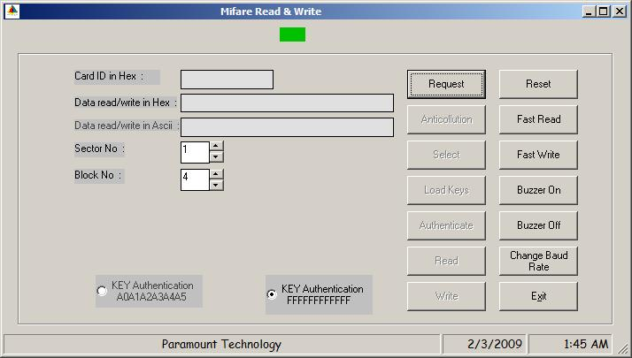

Figure 1: Mifare Read & Write

This software allows the user to write the tag information in Hexadecimal as well as in ASCII. User can select the sector and block number where the information has to be stored in the tag. Mifare has many features which can be enabled at the time of writing like anti-collision, baud rate, beep sound on/off. This software allows the key authentication feature to detect the unauthorized tags. By making use of these functions, tags are written with ASCII A, B, C, D, E with KEY authentication as “FFFFFFFFFFFF”.

### Installation of Microcontroller and Ethernet Development Board

The following instructions illustrate how to setup the microcontroller and Ethernet development board. Figure 5 shows the connection of microcontroller development board and Ethernet development board.

1. Connect the AB4 Ethernet Development Board to the C8051F120 Microcontroller target board at J24. Apply slight pressure to ensure the mating 96-pin connectors are firmly connected.
2. By making use of ribbon cable connect the USB debug adapter to the C8051F120 target board at the JTAG header.
3. Connect the one end of the USB cable to the available USB port of the PC. Connect the other end of the USB cable into the USB connector of the debug adapter.
4. Connect the AC/DC adapter to the C8051F120 target board at P1. This connection should power both the boards. Power is indicated by “PWR”.

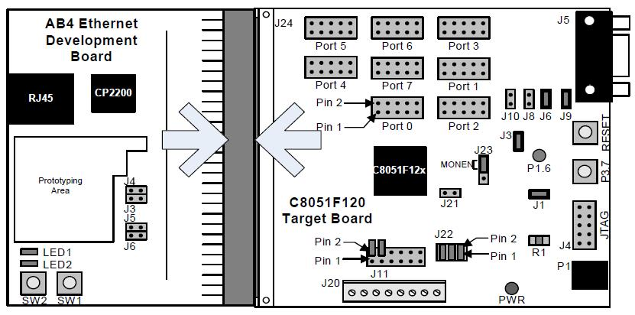

Figure 25: Embedded Ethernet Development board attachment

### Network setup

The Embedded Ethernet Development Kit can be connected to the Ethernet network using a standard Ethernet cable or directly to a PC using a crossover cable. Figure 6 shows the Embedded Ethernet connection using a standard cable.

As the Figure 6 shows the AB4 Ethernet Development Board is connected to an Ethernet wall outlet or to a router/switch using a standard Ethernet cable. A PC is also connected to the same Ethernet network using a standard Ethernet cable.

For a PC to recognize an embedded system on a network, its IP address and subnet mask need to be configured. Below are a few guidelines for choosing an IP address for the embedded system.

1. Find the IP address and Subnet mask for the PC. If a default gateway is specified, then save this address for later use.
2. The IP address chosen for the embedded system must match the PC’s IP address in all bit locations where the Subnet mask is 1 in order for the PC to recognize the embedded system. Otherwise, the PC will send its request outside of the local network.
3. Do not duplicate IP addresses or select a broadcast address. An IP address is considered as a broadcast address if all bits which are 0 in the Subnet mask are 1 in the IP address.
4. The address 255.255.255.255 is known as the Ethernet broadcast address and is used when the Subnet mask for the network is not known. Any packet transmitted to this address will reach all nodes on the local network but cannot go further than the nearest router.

### Building the project

Connect the system as shown in Figure 7. Once the IP address for AB4 Ethernet development board has been set, the microcontroller is ready for the programming. The following is the explanation of major functions for this project.

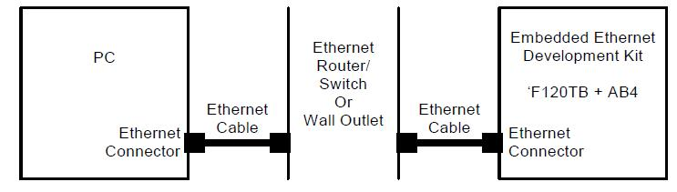

Figure 6: Embedded Ethernet Network Connection (Standard Cable)

The main function of the main.c is to load the webpage for digital parking system. Three more programming codes have been used for the functioning of the system. MN_callback.c is used for updating the webpage content. Serial.c program is used for sending commands to the RFID reader. The main.c will call the serial.c function throughout the working of the system. For the RFID reader to work properly, the manufacturers’ protocols has to be followed. The smartcard.c is used to set the features like anti-collision, select and load keyset, and authentication. Serial.c function will call the smartcard.c program to ensure that the authentic smart card is read. Whenever a car enters into a parking lot, the reader will detect the RFID tag in the car, and the smartcard.c program will make sure the card have been issued earlier by checking the authentication key and ASCII code.

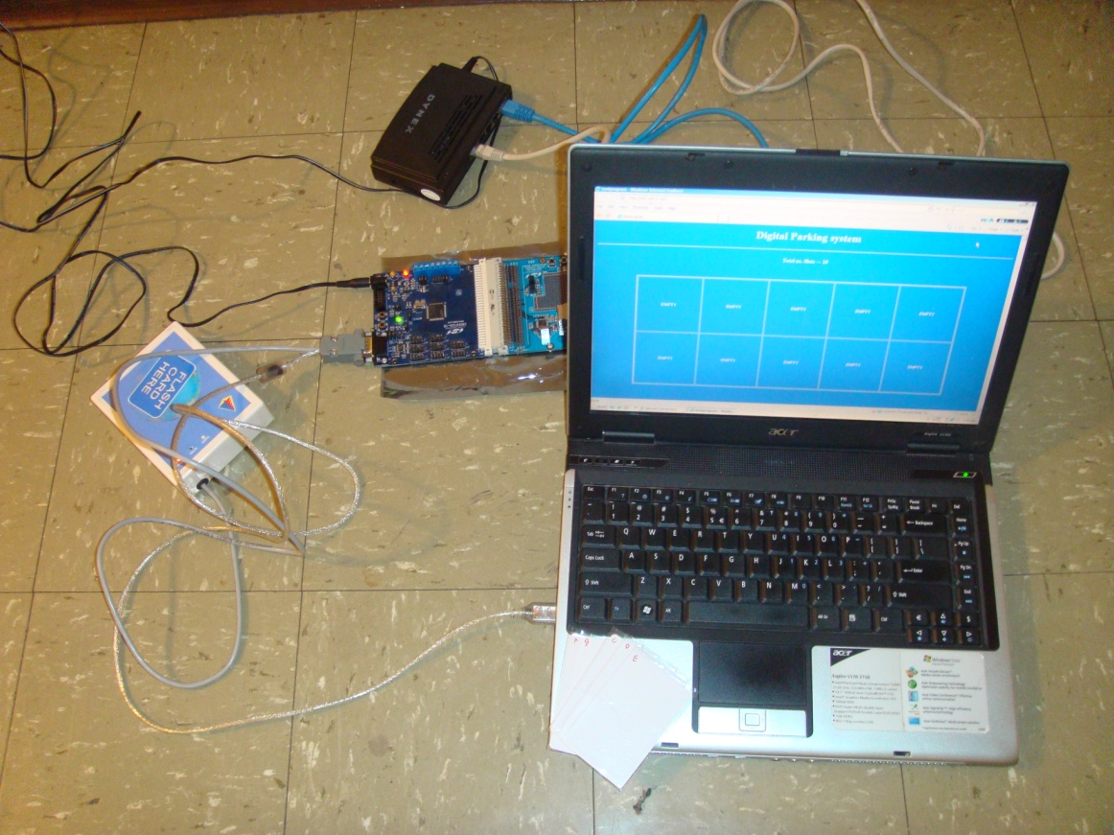

Figure 7: System connections

### Updating the file arrays using CMX HTML2C

A web server content is added to the project in the form of file arrays because the cross compiler used by the microcontroller can only understand C- language and Hex code. The HTML2C utility reads any file (HTML, images, executable binary files, etc.) and generates two files naming original_filename.h and original_filename.c that can be added to the project. Once the index.html is dragged and dropped into the HTML2C conversion space, it will create index.c and index.h which are used in the digital parking system execution.

### Execution and viewing the result

After including the HTML code in the main program, the system has to be compiled once again for making sure that it has zero errors. Once the program code is compiled with zero errors, the embedded system can be removed from the PC. Now the flash memory is loaded with digital parking system code and ready to function. In this process the embedded system and RFID system were connected in Master-Slave configuration. The advantage in making the embedded server as a master is that the microcontroller functions with clock period. Microcontroller will prompt the RFID for every 13 msec. If the reader scans any tag in that time, it will send a response to microcontroller along with the scanned data. The web page will be downloaded as shown in Figure 8.

# 

Figure 38: Web page for digital parking system

All the car parking slots are initially empty. Whenever a car enters into a parking lot, one slot will be turned into car symbol, showing the parking lot user arrives. Figure 9 shows digital parking system when filled with one car.

# 

Figure 9: Digital parking system output when filled with one car

**IV. Conclusions**

By making use of the Paramount’s RFID kit and Silicon labs’ C8051F120 microcontroller and AB4 Ethernet development board, a digital parking lot management system was designed and implemented in this project. With this digital parking system, a car with authorized RFID tag can fast enter the parking lot without manually scanning the parking permit. This parking system will also help users view the availability of the parking space remotely. Therefore, this system helped user reduce the wasting time of search parking lot and also improve the parking lot utilization.

**References**

[1]. GAO RFID Inc., “RFID Enabled Automated Parking Access Control Systems”, Retrieved May 5th, 2009 <http://parking.gaorfid.com/>

[2] Banks, J., Hanny, D., Pachano, M. A., and Thompson, L. G. *RFID Applied.* John Wiley and Sons, 2007.

[3] Mazidi, M. A., and Mazidi, J. G., *The 8051 Microcontroller and Embedded Systems.* Pearson Education, 2006

[4] Silicon Laboratories. (2008). “*Embedded Ethernet Development Kit's User Guide”*. Retrieved October 15, 2008 <https://www.silabs.com/Support%20Documents/TechnicalDocs/Ethernet-DK.pdf>



Dr. XIAOLONG LI received his bachelor and master degrees in electrical and information engineering department at the Huazhong University of Science and Technology, Wuhan, China, in 1999 and 2002, respectively. He received his Ph.D. degree in electrical and computer engineering department at the University of Cincinnati in 2006. He joined the Morehead State University in 2006, where he was an assistant professor in the department of Industrial and Engineering Technology. In 2008, he joined the department of Electronics, Computer and Mechanical Engineering Technology at the Indiana State University, where he is currently an assistant professor.  Dr. Li teaches courses of computer programming, computer electronics, computer networking, etc. His current research interest is in the areas of wireless and mobile networking and microcontroller-based applications.

Mr. Uma Kanth Ranga is a master student in the department of Electronics, Computer and Mechanical Engineering Technology at the Indiana State University. His major research interest is in the area of microcontroller-based applications.